
CO2_AT3 - CASE STUDY DATA HANDLING AND DATA VISUALIZATION
Prithika BH
192424403
Instructions:
For each question, write the program in the specified language (R or Python), generate the required
visualization, and answer the interpretation sub-questions clearly with justification. Case Study 1 – Retail Sales Performance Dashboard
Scenario
A retail company has collected one year of sales data from five regions (North, South, East, West, Central). The dataset contains monthly sales, product categories, customer segments, and total revenue.
The management wants to identify:
• The highest-performing region.
• Monthly sales trends.
• Revenue contribution of each product category.
• Relationship between advertising expenditure and sales.
• Sales distribution across regions.
Tasks
1. Select the most suitable visualization for each requirement:
o Regional revenue comparison
o Monthly sales trend
o Product category contribution
o Advertising expenditure vs sales
o Regional sales distribution
Suitable Visualizations
Requirement Suitable Visualization Regional revenue comparison Bar Plot
Monthly sales trend Stacked Bar Chart Product category contribution Stacked Bar Chart Advertising expenditure vs Sales Scatter Plot
Regional sales distribution Histogram and Density Plot
2. Using R, create:
o Bar Plot
o Stacked Bar Chart
o Histogram
o Density Plot
o Scatter Plot
Program:
library(ggplot2)
sales <- data.frame(
Month = factor(month.abb, levels = month.abb),
Region = c("North","South","East","West","Central", "North","South","East","West","Central",
"North","South"),
Sales = c(120,150,130,170,160,180,175,165,200,190,210,205), Revenue = c(250,300,270,340,320,360,355,345,390,380,410,400), Category = c("Electronics","Clothing","Furniture", "Electronics","Clothing","Furniture",
"Electronics","Furniture","Clothing",
"Electronics","Furniture","Clothing"),
Advertisement = c(30,35,33,40,38,42,44,41,48,46,52,50) )
ggplot(sales, aes(x = Region, y = Revenue, fill = Region)) + geom_bar(stat = "identity") +
labs(title = "Regional Revenue Comparison",
x = "Region",
y = "Revenue") +
theme_minimal()
ggplot(sales, aes(x = Month, y = Sales, fill = Category)) + geom_bar(stat = "identity") +
labs(title = "Monthly Sales by Product Category", x = "Month",
y = "Sales") +
theme_minimal()
ggplot(sales, aes(x = Sales)) +
geom_histogram(binwidth = 15,
fill = "skyblue",
color = "black") +
labs(title = "Sales Distribution",
x = "Sales",
y = "Frequency") +
theme_minimal()
ggplot(sales, aes(x = Sales)) +
geom_density(fill = "orange",
alpha = 0.5) +
labs(title = "Density Plot of Sales",
x = "Sales",
y = "Density") +
theme_minimal()
ggplot(sales, aes(x = Advertisement,
y = Sales,
color = Region)) +
geom_point(size = 4) +
labs(title = "Advertisement Expenditure vs Sales", x = "Advertisement Expenditure",
y = "Sales") +
theme_minimal()
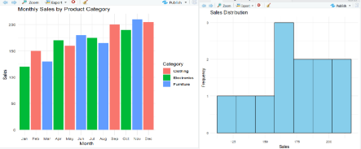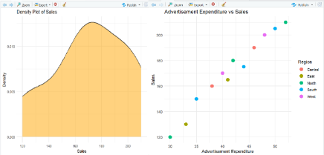3. Interpret:
o Which region generated the highest revenue?
o Is there a positive relationship between advertising expenditure and sales? o Which product category contributes the highest percentage of revenue?
The West region generated the highest revenue among all regions. The scatter plot indicates a positive relationship between advertising expenditure and sales, showing that higher advertising generally leads to higher sales. The Electronics category contributes the highest percentage of total revenue.
Case Study 2 – University Student Performance Analysis
Scenario
A university stores examination data for four departments:
• Computer Science
• Information Technology
• Electronics
• Mechanical
The dataset includes:
• Semester marks
• Attendance percentage
• CGPA
• Placement status
The academic committee wants to evaluate student performance and placement readiness. Tasks
1. Choose appropriate visualizations for:
o Department-wise average marks
o Distribution of CGPA
o Placement percentage
o Attendance vs CGPA relationship
o Semester-wise performance trend
Suitable Visualizations
Requirement Suitable Visualization
Department-wise average marks Grouped Bar Chart
Distribution of CGPA Histogram with Density Curve
Placement percentage Grouped Bar Chart
Attendance vs CGPA relationship Scatter Plot
Semester-wise performance trend Line Chart
2. Develop the following in R:
o Grouped Bar Chart
o Violin Plot
o Histogram with Density Curve
o Scatter Plot
o Line Chart
Program:
library(ggplot2)
students <- data.frame(
Department = c("Computer Science","Information Technology", "Electronics","Mechanical",
"Computer Science","Information Technology",
"Electronics","Mechanical"),
Semester = c(1,1,1,1,2,2,2,2),
Marks = c(85,80,78,74,88,84,81,76),
Attendance = c(95,90,88,85,96,92,89,86),
CGPA = c(9.2,8.9,8.5,8.0,9.4,9.1,8.7,8.2),
Placement = c("Placed","Placed","Placed","Not Placed", "Placed","Placed","Placed","Placed")
)
ggplot(students,
aes(x = Department, y = Marks, fill = factor(Semester))) + geom_bar(stat = "identity", position = "dodge") +
labs(title = "Department-wise Average Marks",
x = "Department",
y = "Marks",
fill = "Semester") +
theme_minimal()
ggplot(students,
aes(x = Department, y = CGPA, fill = Department)) + geom_violin() +
labs(title = "CGPA Distribution by Department",
x = "Department",
y = "CGPA") +
theme_minimal()
ggplot(students,
aes(x = CGPA)) +
geom_histogram(aes(y = ..density..),
binwidth = 0.2,
fill = "skyblue",
color = "black") +
geom_density(color = "red", linewidth = 1) +
labs(title = "Distribution of CGPA",
x = "CGPA",
y = "Density") +
theme_minimal()
ggplot(students,
aes(x = Attendance,
y = CGPA,
color = Department)) +
geom_point(size = 4) +
labs(title = "Attendance vs CGPA",
x = "Attendance (%)",
y = "CGPA") +
theme_minimal()
ggplot(students,
aes(x = Semester,
y = Marks,
color = Department,
group = Department)) +
geom_line(linewidth = 1) +
geom_point(size = 3) +
labs(title = "Semester-wise Performance Trend",
x = "Semester",
y = "Marks") +
theme_minimal()
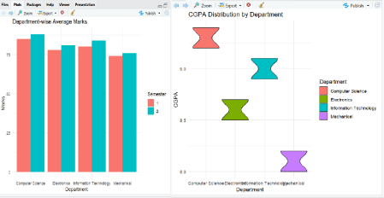
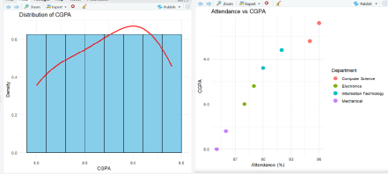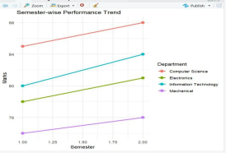
3. Interpret:
o Which department has the highest average CGPA?
o Does higher attendance improve CGPA?
o Which department has the highest placement rate?
The Computer Science department has the highest average CGPA. The scatter plot shows a positive relationship between attendance and CGPA, indicating that students with higher attendance generally achieve better CGPA. The Computer Science department also has the highest placement rate.
Case Study 3 – Hospital Patient Analytics
Scenario
A multi-specialty hospital records patient information including: • Department
• Age
• Treatment cost
• Recovery time
• Disease category
• Admission month
Hospital administrators want to improve resource planning. Tasks
1. Select suitable visualizations for:
o Monthly patient admissions
o Distribution of treatment costs
o Disease category proportions
o Age vs recovery time
o Department-wise treatment costs
Suitable Visualizations
Requirement Suitable Visualization Monthly patient admissions Heatmap
Distribution of treatment costs Histogram
Disease category proportions Density Plot
Age vs Recovery Time Scatter Plot
Department-wise treatment costs Violin Plot
2. Create in R:
o Heatmap
o Histogram
o Violin Plot
o Density Plot
o Scatter Plot
program
library(ggplot2)
hospital <- data.frame(
Department = c("Cardiology","Neurology","Orthopedics","Pediatrics", "Cardiology","Neurology","Orthopedics","Pediatrics"),
Age = c(45,60,35,12,50,65,40,15),
TreatmentCost = c(50000,70000,40000,25000,55000,75000,42000,28000), RecoveryTime = c(10,15,8,5,12,18,9,6),
Disease = c("Heart","Brain","Bone","Child",
"Heart","Brain","Bone","Child"),
Month = c("Jan","Jan","Feb","Feb","Mar","Mar","Apr","Apr") )
ggplot(hospital, aes(x = Month, y = Department, fill = TreatmentCost)) + geom_tile() +
labs(title = "Monthly Patient Admissions Heatmap",
x = "Month",
y = "Department") +
theme_minimal()
ggplot(hospital, aes(x = TreatmentCost)) +
geom_histogram(binwidth = 10000,
fill = "skyblue",
color = "black") +
labs(title = "Treatment Cost Distribution",
x = "Treatment Cost",
y = "Frequency") +
theme_minimal()
ggplot(hospital, aes(x = Department,
y = TreatmentCost,
fill = Department)) +
geom_violin() +
labs(title = "Department-wise Treatment Costs",
x = "Department",
y = "Treatment Cost") +
theme_minimal()
ggplot(hospital, aes(x = TreatmentCost,
fill = Disease)) +
geom_density(alpha = 0.5) +
labs(title = "Density Plot by Disease Category",
x = "Treatment Cost",
y = "Density") +
theme_minimal()
ggplot(hospital, aes(x = Age,
y = RecoveryTime,
color = Department)) +
geom_point(size = 4) +
labs(title = "Age vs Recovery Time",
x = "Age",
y = "Recovery Time (Days)") +
theme_minimal()
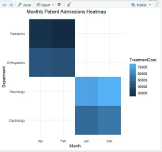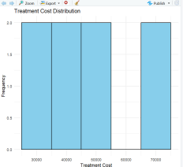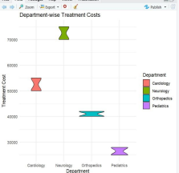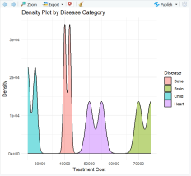
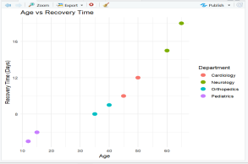3. Interpret:
o Which department has the highest treatment cost? o
Which disease category occupies the largest proportion?
o Is patient age associated with recovery time?
The Neurology department has the highest treatment cost among all departments. The Brain disease category occupies the largest proportion of treatment costs in the dataset. The scatter plot indicates a positive association between patient age and recovery time, with older patients generally taking longer to recover.
Case Study 4 – Smart City Traffic Monitoring
Scenario
A smart city collects traffic sensor data from different junctions. The dataset contains: • Junction
• Time of day
• Vehicle count
• Vehicle type
• Average speed
• GPS coordinates
City planners aim to reduce traffic congestion.
Tasks
1. Select suitable visualizations for:
o Vehicle count comparison
o Hourly traffic trend
o Vehicle type proportion
o Traffic density by location
o Relationship between traffic volume and average speed Suitable Visualizations
Requirement Suitable Visualization Vehicle count comparison Bar Plot Hourly traffic trend Line Chart Vehicle type proportion Pie Chart Traffic density by location Geospatial Map Relationship between traffic volume and average speed Scatter Plot
2. Using R, create:
o Bar Plot
o Line Chart
o Pie Chart
o Geospatial Map
o Scatter Plot
Program
library(ggplot2)
library(maps)
traffic <- data.frame(
Junction = c("J1","J2","J3","J4","J1","J2","J3","J4"),
Hour = c(8,8,8,8,18,18,18,18),
VehicleCount = c(250,320,280,350,420,500,450,550),
VehicleType = c("Car","Bus","Bike","Car","Bus","Car","Bike","Bus"), AverageSpeed = c(45,40,42,38,30,25,28,22),
Longitude = c(77.59,77.60,77.61,77.62,77.59,77.60,77.61,77.62), Latitude = c(12.97,12.98,12.99,13.00,12.97,12.98,12.99,13.00)
)
ggplot(traffic, aes(x = Junction, y = VehicleCount, fill = Junction)) +
geom_bar(stat = "identity") +
labs(title = "Vehicle Count by Junction",
x = "Junction",
y = "Vehicle Count") +
theme_minimal()
ggplot(traffic, aes(x = Hour, y = VehicleCount, group = Junction, color = Junction)) + geom_line(linewidth = 1) +
geom_point(size = 3) +
labs(title = "Hourly Traffic Trend",
x = "Hour",
y = "Vehicle Count") +
theme_minimal()
vehicle_data <- data.frame(
Type = c("Car","Bus","Bike"),
Count = c(3,3,2)
)
gplot(vehicle_data, aes(x = "", y = Count, fill = Type)) +
geom_bar(stat = "identity", width = 1) +
coord_polar("y") +
labs(title = "Vehicle Type Proportion") +
theme_void()
ggplot(traffic, aes(x = Longitude, y = Latitude,
size = VehicleCount, color = VehicleCount)) +
geom_point() +
labs(title = "Traffic Density by Location",
x = "Longitude",
y = "Latitude") +
theme_minimal()
ggplot(traffic, aes(x = VehicleCount,
y = AverageSpeed,
color = Junction)) +
geom_point(size = 4) +
labs(title = "Traffic Volume vs Average Speed",
x = "Vehicle Count",
y = "Average Speed") +
theme_minimal()
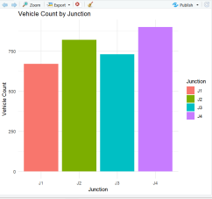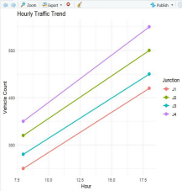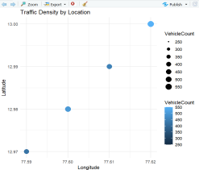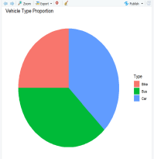
3. Interpret:
o Which junction experiences the highest congestion?
o During which hours is traffic highest?
o Does increased traffic reduce vehicle speed?
The J4 junction experiences the highest congestion because it records the highest vehicle count. Traffic is highest during the 18:00 (evening) hours. The scatter plot shows that as traffic volume increases, the average vehicle speed decreases, indicating a negative relationship between traffic volume and speed.
Case Study 5 – Social Media User Interaction Analysis
Scenario
A digital marketing company analyzes data from a social media platform. The dataset includes: • User ID
• Followers
• Likes
• Shares
• Comments
• Posting time
• User interactions
The company wants to understand engagement patterns and user networks. Tasks
1. Select appropriate visualizations for:
o Distribution of likes
o Relationship between followers and engagement
o User interaction network
o Posting activity over time
o Multivariate comparison of likes, shares, and comments
Suitable Visualizations
Requirement Suitable Visualization Distribution of likes Histogram with Density Curve
Requirement Suitable Visualization Relationship between followers and engagement Scatter Plot User interaction network Network Visualization Posting activity over time Temporal Line Plot Multivariate comparison of likes, shares and comments Heatmap 2. Develop in R:
o Histogram with Density Curve
o Scatter Plot
o Network Visualization
o Temporal Line Plot
o Heatmap
Program
library(ggplot2)
library(igraph)
social <- data.frame(
UserID = c("U1","U2","U3","U4","U5","U6"),
Followers = c(1000,1500,2000,1200,2500,1800),
Likes = c(300,450,600,350,700,500),
Shares = c(80,120,150,90,180,130),
Comments = c(60,90,110,70,140,100),
PostingTime = c(8,10,12,14,18,20)
)
ggplot(social, aes(x = Likes)) +
geom_histogram(aes(y = ..density..),
binwidth = 100,
fill = "skyblue",
color = "black") +
geom_density(color = "red", linewidth = 1) +
labs(title = "Distribution of Likes",
x = "Likes",
y = "Density") +
theme_minimal()
ggplot(social,
aes(x = Followers,
y = Likes,
color = UserID)) +
geom_point(size = 4) +
labs(title = "Followers vs Engagement",
x = "Followers",
y = "Likes") +
theme_minimal()
edges <- data.frame(
from = c("U1","U1","U2","U3","U4","U5"), to = c("U2","U3","U4","U5","U6","U6") )
g <- graph_from_data_frame(edges)
plot(g,
vertex.color = "skyblue",
vertex.size = 30,
vertex.label.cex = 1,
main = "User Interaction Network")
ggplot(social,
aes(x = PostingTime,
y = Likes,
group = 1)) +
geom_line(color = "blue", linewidth = 1) + geom_point(size = 3) +
labs(title = "Posting Activity Over Time", x = "Posting Time",
y = "Likes") +
theme_minimal()
metrics <- data.frame(
User = rep(social$UserID, 3),
Metric = rep(c("Likes","Shares","Comments"), each = 6),
Value = c(social$Likes,
social$Shares,
social$Comments)
)
ggplot(metrics,
aes(x = Metric,
y = User,
fill = Value)) +
geom_tile() +
labs(title = "Likes, Shares and Comments Heatmap", x = "Metric",
y = "User") +
theme_minimal()
3. Interpret:
o Which users are the most influential?
o At what time is engagement highest?
o Is there a strong relationship between followers and total engagement? o Identify highly connected users from the network visualization. o Which engagement metric (likes, shares, or comments) varies the most across users?
The most influential users are U5 and U3, as they have the highest followers and engagement. User engagement is highest around 18:00, where the maximum number of likes is observed. There is a strong positive relationship between followers and total engagement, U5 and U6 appear as highly connected users in the network visualization, and likes show the greatest variation across users.

